Access Partners with The UniteCT Mobile Bus for the Northeast Corner
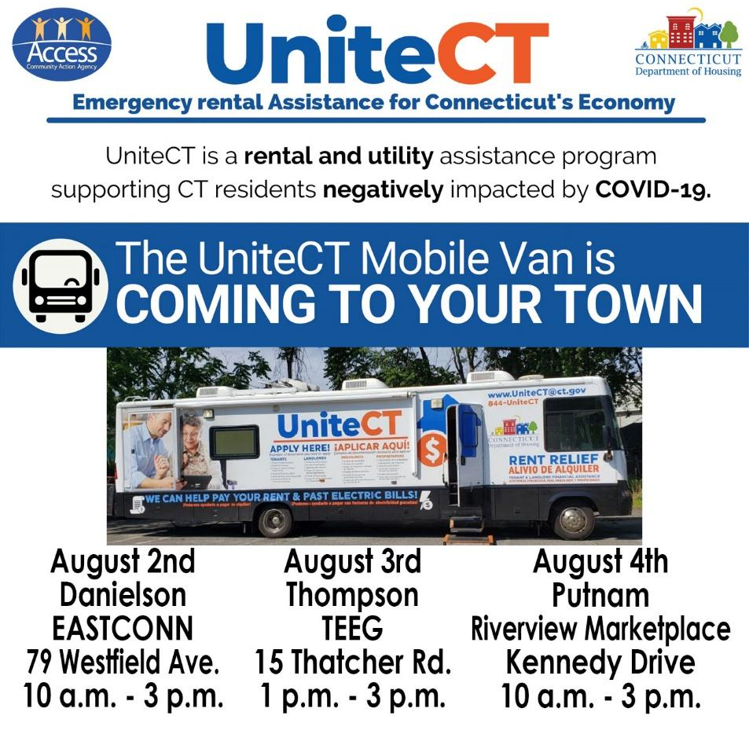
Danielson, CT - Access Community Action Agency partners with UniteCT to bring much needed rental and utility help to residents in the rural Northeast corner. The UniteCT bus travels to help communities with limited access to technology apply for rental and electricity payment relief. The Bus will be visiting Danielson at EASTCONN on 79 Westfield Avenue on August 2nd from 10 a.m. to 3 p.m.; Thompson at TEEG on 15 Thatcher Road on August 3rd from 1 p.m. to 3 p.m.; and Putnam at the Riverview Marketplace on Kennedy Drive on August 4th from 10 a.m. to 3 p.m. Walk-in appointments are welcomed at the bus or you can find the link to sign up for an appointment time on the UniteCT website.

UniteCT is a state program to provide rental and utility assistance to qualified Connecticut households financially impacted by COVID-19. UniteCT is providing financial support for families earning up to 80% of HUD's area median income. This program may provide up to $15,000 in rental assistance and up to $1,500 in electric utility arrearage payments to landlords and utility companies on behalf of approved tenants. Tenants and landlords will be able to complete and track applications online from any computer or smartphone. For information on eligibility, necessary documentation to apply, and instructions on how to apply visit the UniteCT website for more information.

Customers negatively impacted by COVID-19 and in need of financial help can call (860) 412-1600 ext. 1628 in Danielson or (959) 929-7981 in Willimantic, or email unitect@accessagency.org.
The Access Community Action Agency is designated by the federal and state government as the anti-poverty agency in northeast Connecticut. Access provides food, affordable housing, job readiness services, and other pathways to economic self-reliance for vulnerable limited-income families and individuals throughout the region.

